AnkiDriod-7070

ID-62

Apk

AnkiDroid-2.12.1-x86.apk

<https://github.com/ankidroid/Anki-Android/releases?q=2.12.1&expanded=true>

Bug report description

**1.Original but report:**

**Link**

[**https://github.com/ankidroid/Anki-Android/issues/7070**](https://github.com/ankidroid/Anki-Android/issues/7070)

**Reproduction Steps**

1. Open card browser.
2. Choose the option "filter by tag".
3. Choose any tag.

**Expected Result**

Cards with specified tags should have appeared.

**Actual Result**

No cards appear.

**Debug info**

AnkiDroid Version = 2.12.1

Android Version = 9

ACRA UUID = 8203f6ea-11a2-493a-ab0d-d4999512b3ed

Screen shots sequence

Prerequisites:

**Download a complex deck to AVD:**

<https://drive.google.com/u/0/uc?id=1vTHQFSxPLBqfbGcovW95ZfeAJFWrS1WX&export=download>

**Import it to AnkiDriod:**

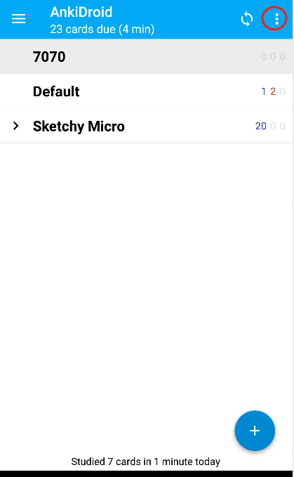

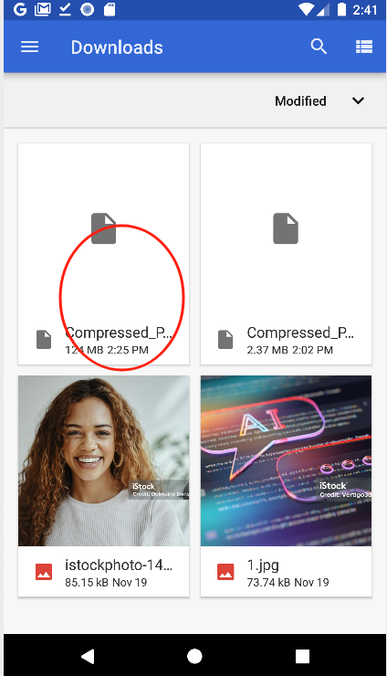

**Bug reproduction sequence:**

